**21L-7512 ABDULLAH DAR BSCS-5G1**

**Computer Networks**

**LAB no 10**

**Question no 1:**

**CODE:**

#21L7512 ABDULLAH DAR BSCS 5G1 lab no Q1  
#Q1- RING TOPOLOGY  
  
#Making Simulator  
set simulator [new Simulator]  
$simulator  rtproto DV  
  
set nsf [open out.nam w]  
$simulator  namtrace-all $nsf  
  
proc finish {} {  
        global simulator  nsf  
        $simulator  flush-trace  
        close $nsf  
        exec nam out.nam  
        exit 0  
        }  
  
  
#Making nodes  
for {set i 0} {$i<7} {incr i} {  
set n($i) [$simulator  node]  
}  
  
  
#Making links  
for {set i 0} {$i<7} {incr i} {  
$simulator  duplex-link $n($i) $n([expr ($i+1)%7]) 512Kb 5ms DropTail  
}  
  
$simulator  duplex-link-op $n(0) $n(1) queuePos 1  
$simulator  duplex-link-op $n(0) $n(6) queuePos 1  
  
#Making udp agent and attching to node 0  
set udp [new Agent/UDP]  
$simulator  attach-agent $n(0) $udp  
  
  
#Making Null agent and attaching to node 3  
set null [new Agent/Null]  
$simulator  attach-agent $n(3) $null  
$simulator  connect $udp $null  
  
#CBR agent  
set cbr [new Application/Traffic/CBR]  
$cbr set packetSize_ 1024  
$cbr set interval_ 0.01  
$cbr attach-agent $udp  
  
$simulator  rtmodel-at 0.4 down $n(2) $n(3)  
$simulator  rtmodel-at 1.0 up $n(2) $n(3)  
  
$simulator  at 0.01 "$cbr start"  
$simulator  at 1.5 "$cbr stop"  
  
$simulator  at 2.0 "finish"  
$simulator  run

**ScreenShots:**

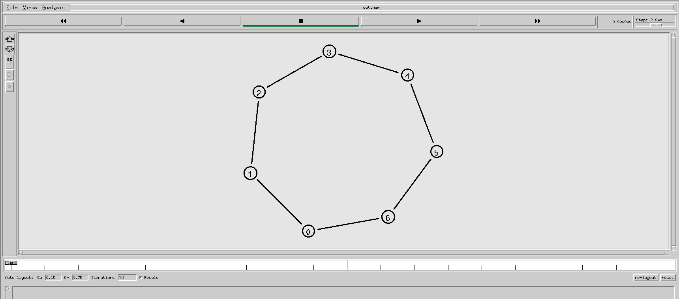

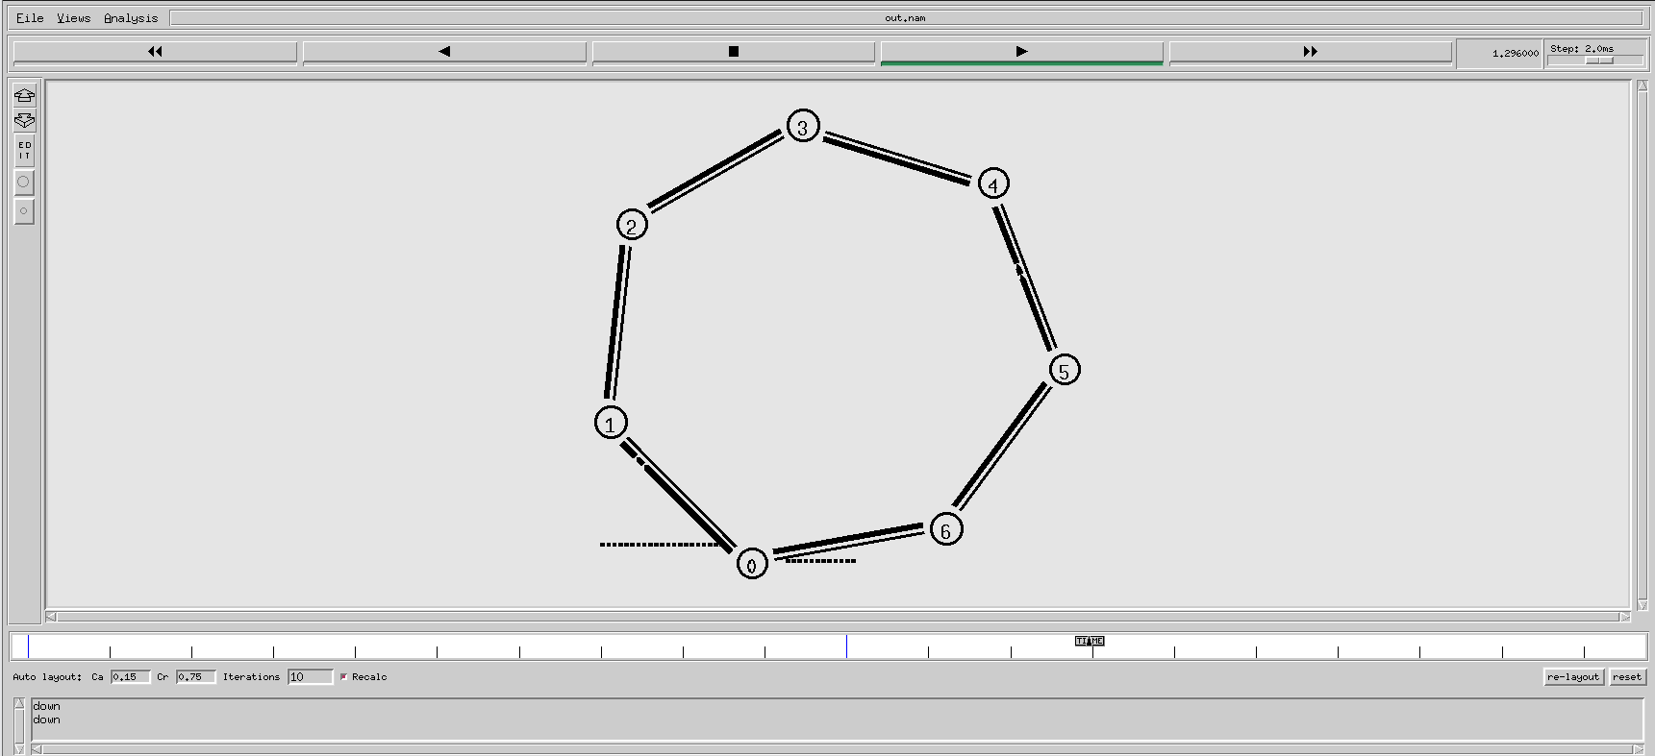

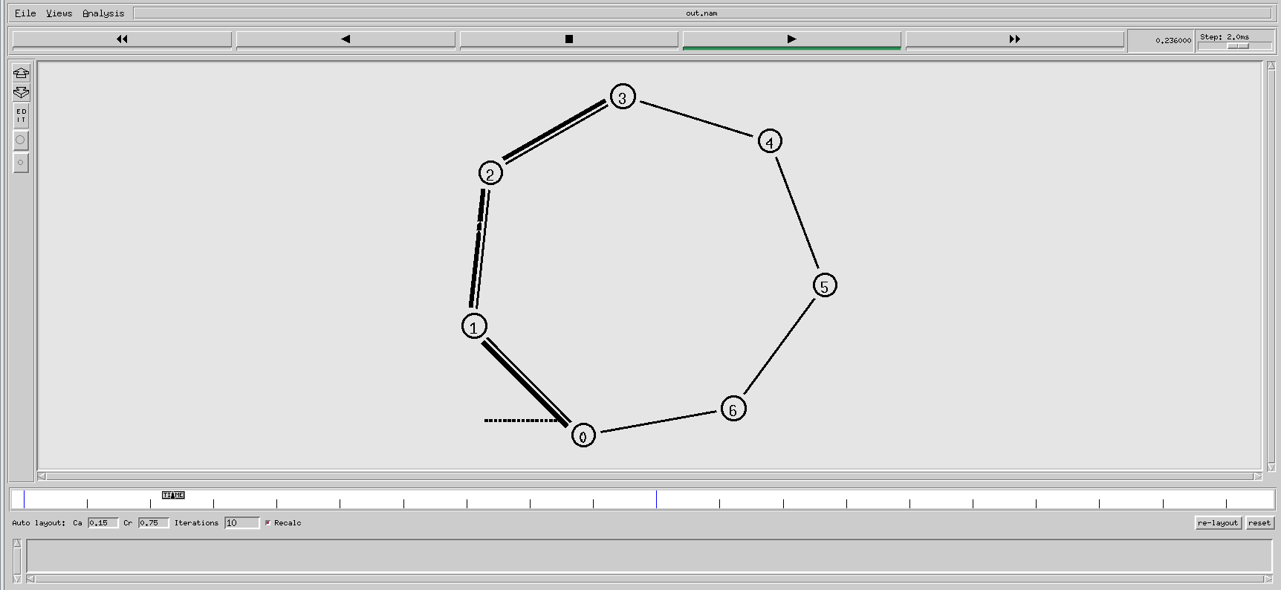

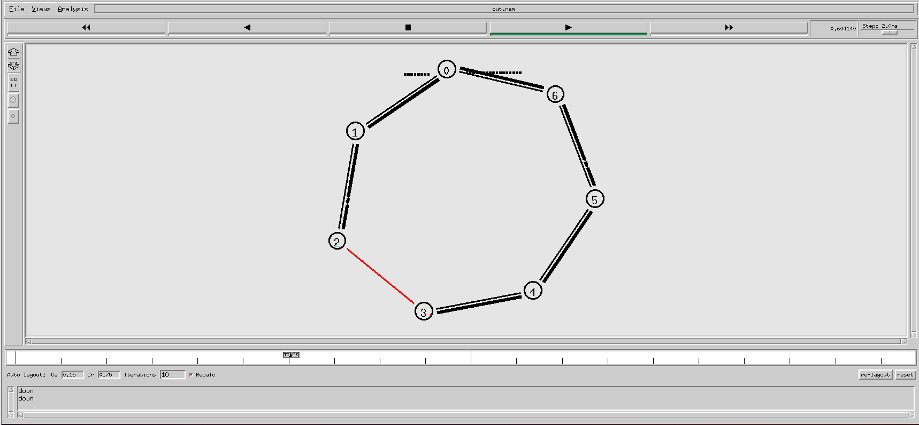

**Question no 2:**

**CODE:**

#21L7512 ABDULLAH DAR BSCS 5G1 lab no Q2  
#Q2- STAR TOPOLOGY  
  
set simulator [new Simulator]  
  
$simulator color 1 blue  
$simulator color 2 red  
  
$simulator rtproto DV  
set nsf [open out.nam w]  
$simulator namtrace-all $nsf  
  
proc finish {} {  
        global simulator nsf  
        $simulator flush-trace  
        close $nsf  
        exec nam out.nam  
        exit 0  
        }  
  
#Making Nodes          
for {set i 0} {$i<7} {incr i} {  
set n($i) [$simulator node]  
}  
  
#Making Links  
for {set i 1} {$i<7} {incr i} {  
$simulator duplex-link $n(0) $n($i) 512Kb 10ms SFQ  
}  
  
#Orienting nodes  
$simulator duplex-link-op $n(0) $n(1) orient left-up  
$simulator duplex-link-op $n(0) $n(2) orient right-up  
$simulator duplex-link-op $n(0) $n(3) orient right  
$simulator duplex-link-op $n(0) $n(4) orient right-down  
$simulator duplex-link-op $n(0) $n(5) orient left-down  
$simulator duplex-link-op $n(0) $n(6) orient left  
  
#UDP  connection  
set udp [new Agent/UDP]  
$udp set class_ 2  
$simulator attach-agent $n(2) $udp  
  
set null [new Agent/Null]  
$simulator attach-agent $n(5) $null  
  
$simulator connect $udp $null  
  
#TCP connection  
set tcp [new Agent/TCP]  
$tcp set class_ 1  
$simulator attach-agent $n(1) $tcp  
  
set sink [new Agent/TCPSink]  
$simulator attach-agent $n(4) $sink  
  
$simulator connect $tcp $sink  
  
#FTP connection  
set ftp [new Application/FTP]  
$ftp attach-agent $tcp  
  
#CBR connection  
set cbr [new Application/Traffic/CBR]  
$cbr set rate_ 256Kb  
$cbr attach-agent $udp  
  
#setting timings  
$simulator rtmodel-at 0.5 down $n(0) $n(5)  
$simulator rtmodel-at 0.9 up $n(0) $n(5)  
  
$simulator rtmodel-at 0.7 down $n(0) $n(4)  
$simulator rtmodel-at 1.2 up $n(0) $n(4)  
  
$simulator at 0.1 "$ftp start"  
$simulator at 1.5 "$ftp stop"  
  
$simulator at 0.2 "$cbr start"  
$simulator at 1.3 "$cbr stop"  
  
$simulator at 2.0 "finish"  
$simulator run

**ScreenShots:**

